1. Introduction (12 p)
Center the Title, Times New Roman (14p),
First Name Last Name*, Author Name 2**, and Author Name 3***, † (11p)
*Dept. of Welding Science and Engineering, Korea University, Seoul, 10000, Korea (10p)
** 2nd author’s department/organization, Seoul, 10003, Korea
*** 3rd author’s department/organization, Dae-jeon, 30000, Korea
* Corresponding author :
(Received ; Revised ; Accepted )
Abstract
The abstract should not exceed 200 words in length, and should be placed below affiliations. (10p)
abstract here abstract here abstract here abstract here abstract here abstract here abstract here abstract here abstract here abstract here abstract here abstract here abstract here abstract here abstract here abstract
Key Words : Chemical Compositions, Cold cracking, Weldments (10p)
The original typescript should be submitted electronically in A4 size format, with a word count of 5000 (excluding figures), following the submission requirements described on the Journal's website. A final paper which would exceed of 5000 words or occupy more than 10 pages of the Journal may be returned for abridgement.
Each paragraph should be indented two spaces, from left margin. (10p)
Text here, Text here, Text here, Text here, Text here, Text here, Text here, Text here, Text here, Text here, Text here, Text here, Text here, Text here, Text here, Text here, Text here, Text here, Text here, Text here, Text here, Text here, Text here, Text here, Text here, Text here, Text here, Text here, Text here, Text here, Text here

2. Materials (12p)
2.1 Materials (second-level heading, 11p)
Each paragraph should be indented two spaces, from left margin. (10p),
Text here, Text here, Text here, Text here, Text here, Text here, Text here, Text here, Text here, Text here, Text here, Text here, Text here, Text here, Text here, Text here, Text here,
3. Method (12p)
3.1 Experimental Procedure (second-level heading, 11p)
3.1.1 Experimental method (third-level heading, 10p)
Each paragraph should be indented two spaces, from left margin. , (10p)
Text here, Text here, Text here, Text here, Text here, Text here, Text here, Text here, Text here, Text here, Text Text here, Text here, Text here, Text here, Text here, Text here, Text here, Text here, Text here, Text here

Table 1 Table caption (10p, Center)
1 | 2 | 3 | 4 | 5
2 | 4 | 8 | 16 | 32
50.0 | 75.0 | 87.5 | 93.8 | 96.9

4. Result. Discussion (12)
4.1 second-level heading (11p)
Each paragraph should be indented two spaces, from left margin (10P)
Text here, Text here, Text here, Text here, Text here, Text here, Text here, Text here, Text here, Text here, Text here, Text here, Text here, Text here, Text here, Text here, Text here, Text here, Text here, Text here, Text here, Text here,
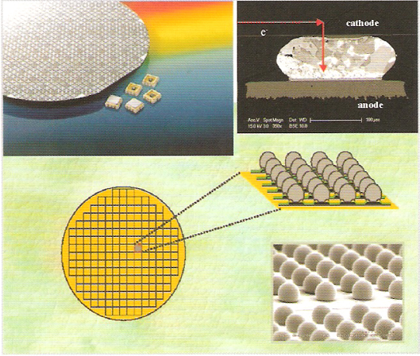
Fig. 1 Figure caption (10p, Center)

5. Conclusion (12p)
Each paragraph should be indented two spaces, from left margin. (10p)
Text here, Text here, Text here, Text here, Text here, Text here, Text here, Text here, Text here, Text here, Text here, Text here, Text here, Text here, Text here, Text here, Text here, Text here, Text here, Text here, Text here,

Acknowledgement (As Required) (12p)
Each paragraph should be indented two spaces, from left margin. (10p)

ORCID: First author: https://orcid.org/
ORCID: Coresponding author: https://orcid.org/
(First author and corresponding author must be written)

References (12p)

1. Y. Kim and K. Y. Park, Micro TIG Welding Characteristics of Stainless Steel Bellows, J. Weld. Join. 33 (2) (2015), 115-119
https://doi.org/ (If there is no DOI, you do not need to write)
2. A. A. Golden berg and A. Bazerghi, Preview approach to force control of robot manipulators, J. Appl. Mech. 20 (5) (1985), 449-464
https://doi.org/

How to prepare a reference
1. Initials name of each author
2. Full title of the cited article, title capitalization
3. Abbreviation name of the journal
4. Volume number (if any) (Do not include the abbreviation, "Vol.")
5. Issue number (if any) in parentheses (Do not include the abbreviation, “No.”)
6. Year of publication
7. Inclusive page numbers of the cited article (Do not include the abbreviation, “pp.”)
8. Number of DOI (if any)

The exemplary form of listed references is as follows:
1. Journal : Author, Title, Journal, Volume(Number) (Year) Page.
S. W. Kim and C. K. Chun, Trend of DED type Additive Manufacturing Technology for Titanium, J. Weld. Join. 35(4) (2017) 327-332.
https://doi.org/10.5781/JWJ.2017.35.4.4
2. Conference : Author, Title, Proceeding, Place (Year) Page.
J. H. Lee, C. H. Kim and N. H. Kang, Hydrogen Diffusion and Embrittlement with Respect to Microstructure of Pipeline Steel Welds, Proceedings of International Welding and Joining Conference (IWJC 2017), Gyeongju, Korea (2017) 3-4.
3. Book : Author, Title, Publisher, Place, Nation (Year) Page.
S. Kou, Welding Metallurgy, 2nd Edition, Wiley Interscience, New Jersey, USA (2003) 433-440.
4. Thesis : Author, Thesis, Title, University, Place (Year) Page.
W. J. Seong, Ph. D. thesis, A Study on Flame Forming and Straightening of Welding Distortion for Shipbuilding Structure, KAIST, Daejeon, Korea (2012) 151.
5. Standard : Standard No., Title, Publisher (Year).
ISO 9455-11, Soft Soldering Fluxes - Test Methods - Part 11; Solubility of Flux Residues, International Standardization Organization (ISO) (2017).

